Hurricane Season 2020 Public Messaging
This hurricane season, during the COVID-19 pandemic, sheltering and evacuation will operate differently than in past years.

Planning and Preparing
- Make a plan to stay with family or friends at a safe place inland, or at a hotel, if you need to evacuate.
- Staying at a storm shelter is not a good option during the COVID-19 pandemic and should only be considered as a last resort.
- Be sure to include supplies in your emergency kit to stay healthy – masks, hand sanitizer, cleaning products, sanitizing wipes.
- Visit ReadyNC.org to learn how to create a family emergency plan and build your emergency supplies kit.

Evacuating
- Protecting yourself from the physical dangers of a hurricane, like storm surge, flooding and high winds, takes priority over concerns about COVID-19.
- If your area is ordered to evacuate – do so quickly and calmly. Don’t forget your emergency kit.
- If you live in a coastal community be sure to Know Your Zone. Find out if you live in a predetermined coastal evacuation zone. Learn more at knowyourzone.nc.gov. Many coastal counties will use these new zones to order evacuations
- Take time now to review your evacuation routes. Plan for a primary route, and an alternate.

Sheltering
- Make a plan to stay with family or friends at a safe place inland, or at a hotel, if you need to evacuate.
- Social distancing will reduce the capacity at shelters this year. Shelter space in many counties will be limited and should be only considered as a last resort.
- Non-congregate sheltering options like dormitories, campgrounds or other facilities where people can maintain distance may be in use during the COVID-19 pandemic. Follow your local government website and social media channels for sheltering information.
- Shelters may not offer cots for sleeping, only safe refuge until a storm passes. Plan to bring you own amenities like food and bedding.
- If you must go to a shelter, follow the CDC guidance to lower the risk of spreading infection:
  - Practice social distancing. Stay at least 6 feet (about 2 arms’ length) from other people outside of your household.
  - Wash your hands often, cover coughs and sneezes, and follow shelter policies for wearing cloth face coverings. Avoid sharing food and drink with anyone if possible.
  - Follow disaster shelter policies and procedures designed to protect everyone in the shelter, particularly older adults (65 and older) and people of any age who have serious underlying medical conditions. These people are at higher risk for severe illness from COVID-19.
  - Avoid touching high-touch surfaces, such as handrails, as much as possible. If not possible, wash hands or use hand sanitizers immediately after you touch these surfaces.
  - Keep your living area clean and disinfect frequently-touched items such as toys, cellphones, and other electronics.
  - If you feel sick when you arrive at the shelter or start to feel sick while sheltering, tell shelter staff immediately.

Social Media graphics

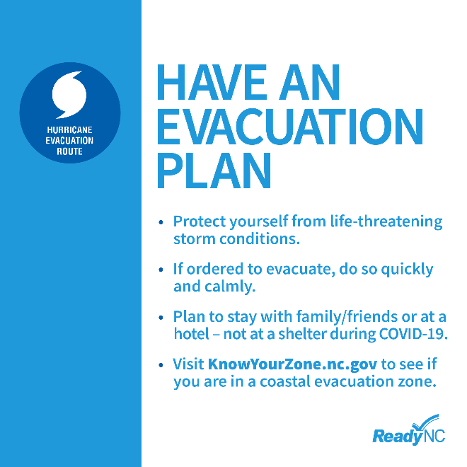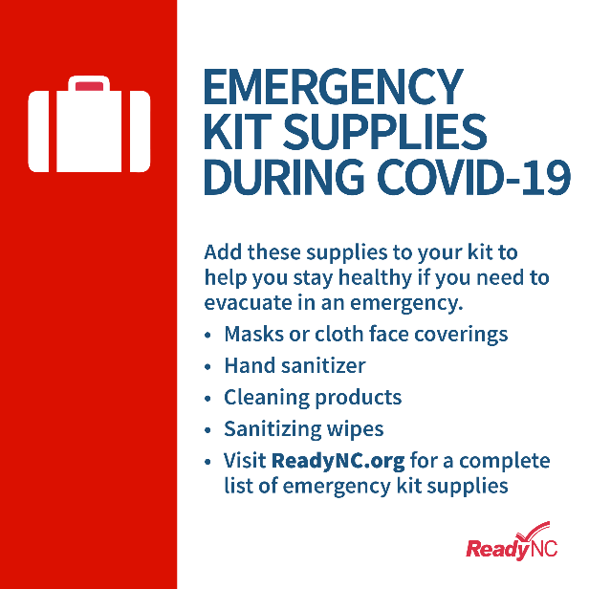

Other resources
NCDHHS Social Media Toolkit for COVID-19

NCEM Social Media Toolkit – Know Your Zone

