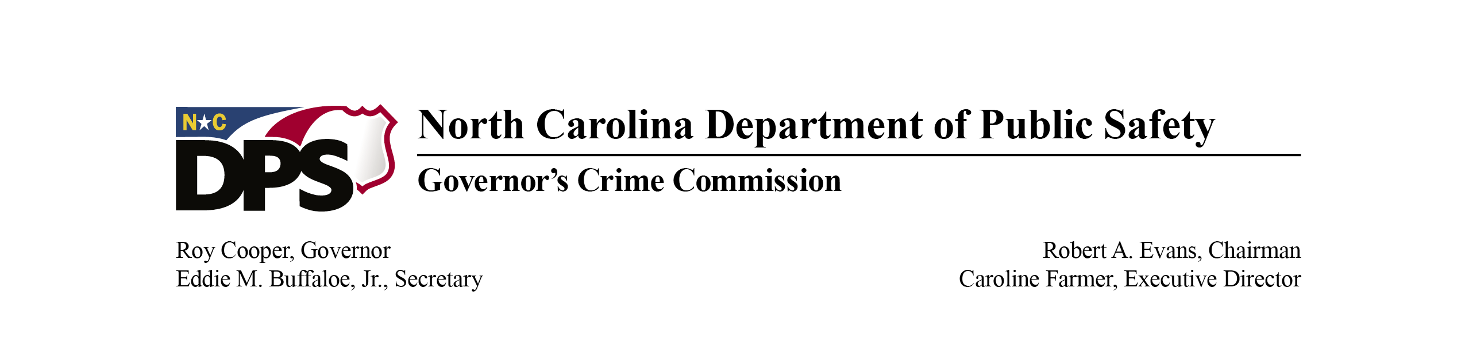

Governor’s Crime Commission Quarterly Meeting

Date: December 7, 2023
Location: Virtual Meeting via WebEx and in-person at 1201 Front Street

In Attendance
Members: Chief Patrice Andrews, Justice Philip Berger Jr., Sheriff Clarence Birkhead, Sheriff Charles Blackwood, Director Ryan Boyce, Secretary Eddie Buffaloe Jr. (represented by Caroline Valand), Commissioner Leto Copeley, Judge Mary Covington, Commissioner Benjamin Curtis, Judge Sherri Elliot, Mayor Don Hardy, Commissioner Jodi Harrison, Commissioner Andrew Hendry, Chief Dan House, Commissioner Karen Howard, Colonel Freddy Johnson, Commissioner Monika Johnson-Hostler, Deputy Secretary William Lassiter, Deputy Secretary Tracy Lee (represented by Theresa Starling), Commissioner Jasmine McGhee, Commissioner Richard Parks, Sherriff Willie Rowe, Director Robert Schurmeier, Director Angela Smith, The Honorable Rebecca Spragins, Reverend Bruce Stanley, Councilman Christopher Suggs, The Honorable Pamela Thompson, Commissioner Tabari Wallace, Chief Michael Yaniero

Staff: Katrina Agasino, Keyon Ashe, Paris Baker, Diane Barber-Whitaker, Michelle Beck, Daun Brown, Keith Bugner, Felicia Byrd, Arienne Cheek, Grace Clougherty, Tom Cook, Sandy Dixon, Robert Epstein, Caroline Farmer, Kevin Farrell, Betty Harrington, Jennifer Johnston, Carolyn Locklear, Jordan Mayer, Adonicca McAllister, Eric McCabe, Pat McDonald, Medwin Metzger, Tanya Ogburn, Navin Puri, Jackie Ray, LaShanya Richardson, Christina Scarano, Burley Spinks, Matthew Stuart, Blake Sykes, Allyson Teem, Brenda Washington, Jason Wimmer, Bria Wortham, Roxana Zelada-Lewis

Guests: Stella Bailey (DHHS), Ryan Boyce, Eddie Caldwell (NC Sheriffs’ Association), Julio Cazares, Emily Chávez (UNC Chapel Hill), Zieu Dalsheim, Tonya Van Deinse (UNC School of Social Work), Tom Donahue, Marie Evitt (NC Sheriffs’ Association), Deena Fulton (UNC School of Social Work), Deborah Garcia-Sandoval (Probation Officer/Handgun Intervention Program Coordinator), Jane Gilchrist (NCDPS), Bonnie Helmink (Director of Applicant Servies), Meredith Hemphill, Brea Hollingsworth (CBS 17), Sherry Hunter (DPS), Chelsea Kancilia (Denver District Attorney’s Office), Diana Kees, Laura Leslie, Julia Metz (UNC-Chapel Hill), TeAndra Miller (LANC), Ryan Oehrli, Josh Panter (NCDAC), Dana Rice (UNC School of Social Work), Mary Kathryn Smith, Bailey Sprazins (CSC), Allison Waters (UNC Chapel Hill), WCTI 12, Morgan Weiss (NCGA), Marc Wilson (CBS 17), Charlotte Woolard (NCDPS), WRAL

Call to Order and Roll Call
Meeting was called to order by Sheriff Charles Blackwood at 9:02 a.m. After welcoming everyone, A quorum was established by roll call with 30 members present and 25 voting members present.

Reminders
Sheriff Charles Blackwood provided the ethics reminder from the NC General Statute, Chapter 138A-35, and other provisions of the State Government Ethics Act. A reminder for recusal was made. No conflicts were raised, and no one verbally recused themselves.

Approval of Minutes
Minutes were sent in advance of the meeting. Time was provided time for discussion of the minutes and a vote was requested for approval. Bruce Stanley moved to accept the minutes. Pamela Thompson seconded the motion. The motion passed unanimously and minutes were approved.

Presentations
GCC Updates: Caroline Farmer informed the commission on the upcoming VOCA funding decrease and on the new GCC grants management system, EBS. She also announced the upcoming federal audit.

Criminal Justice Data
- Michelle Beck from the GCC Criminal Justice Analysis Center presented on the work that the Criminal Justice Analysis Center is doing. There was a handout provided to the commission (attached).

Community Needs Assessment
- Tonya Van Deinse, Dana Rice, and Deena Fulton from the UNC School of Social Work presented additional data on the NC Victims of Crime Community Needs Assessment which will be posted on the website.

Medicaid Expansion
- Stella Bailey from the Department of Health and Human Services presented on Medicaid expansion. (powerpoint attached)
- An extra 600,000 people now have Medicaid in NC and an extra 300,000 are eligible for Medicaid.

Commerce Reentry Initiative
- Bonnie Helmink from the NC Department of Commerce Reentry Initiative presented. (powerpoint attached)

Handgun Intervention Program
- Chelsea Kancilia from Denver District Attorney’s Office and Deborah Garcia-Sandoval the Probation Officer/Handgun Intervention Program Coordinator presented.
- They presented on the youth program they were providing a program for youth with a variety of presenters. These presentations focused on guns and violence.

Old/New Business
No old or new business was brought before the Commission.

Announcements and Adjournment
The next GCC Commission meeting will be held on March 7, 2024 at 9:00 a.m. Mayor Hardy motioned for the adjournment and Judge Sherri Elliot seconded. Chairman Evans adjourned the meeting at 12:00 p.m.

Attachments
- Agenda
- Roll call
- Minutes from prior meeting
- GCC Updates presentation
- Criminal Justice Data handout
- Community Needs Assessment handout
- Community Needs Assessment presentation
- Medicaid Expansion presentation
- Commerce Reentry Initiative handout
- Powerpointss

